A PROJECT REPORT
ON

WIRELESS ELECTRIC VECHILE CHARGING SYSTEM
SUBMITTED IN PARTIAL FULFILLMENT OF THE
REQUIREMENTS FOR THE AWARD OF DEGREE OF

BACHELOR OF ENGINEERING IN ELECTRONICS & COMMUNICATION ENGINEERING
BY

1608-23-735-090 K. SWETHA 1608-23-735-099 R. CHARAN

Under the guidance of
Mr. A. Abhishek Reddy M. Tech, (Ph.D)
Assistant Professor



Department of Electronics and Communication Engineering
(NBA Accredited)

MATRUSRI ENGINEERING COLLEGE
(Sponsored by Matrusri Educational Society, ESTD1980)
(Approved by AICTE, Affiliated to Osmania University)
#16-1-486, Saidabad, Hyderabad, Telangana-500 059
www.matrusri.edu.in
2025-2026


DEPARTMENT OF ELECTRONICS AND COMMUNICATION ENGINEERING

Date: 16-12-2025

Certificate

This is to certify that the Project report entitled “WIRELESS ELECTRIC VEHICLE CHARGING SYSTEM” being submitted by Batch B-23 in partial fulfilment for the award of the Degree of Bachelor of Engineering in Electronics and Communication Engineering of the Osmania University, Hyderabad, during 2025-26 is a record of bonafide work carried out under our guidance and supervision.

Project Coordinators Name of the Guide
Mr. A. Abhishek Reddy Mr. A. Abhishek Reddy
Mr. M. Thirupati Assistant Professor

Dr. N. Srinivasa Rao
HOD-ECE

DECLARATION
This is to declare that the work submitted in the present Project work report titled “WIRELESS ELECTRIC VEHICLE CHARGING SYSTEM” is a record of bonafide work done by me and my team in the Department of Electronics and Communication Engineering, Matrusri Engineering College, Saidabad, Hyderabad.
No part of the report is copied from books, journals, internet and wherever the subject content is taken; the same is duly referred in the text. The report generated is based on the Project work carried out entirely by us and not copied from any other source.

K.Swetha 1608-23-735-090
R.Charan 1608-23-735-099

Place: Hyderabad
Date: 16-12-2025

ACKNOWLEDGEMENT

We would like to take this opportunity to place it on the record, that this project would never have taken shape but for the cooperation extended to us by certain individuals. Though this is not possible to name all of them, it would be a pardonable on us part if we don’t mention some of the very important persons Sincerely we acknowledge our deep sense of gratitude to the project guide, Mr. A. Abhishek Reddy , Assistant Professor for her constant encouragement, help and valuable suggestions. we wish to thank her for constant motivation and help throughout the project.
We would like to express our deep gratitude to the Head of Department Dr. N SRINIVASA RAO and Project Coordinators Mr. A. ABHISHEK REDDY, Mr. M.THIRUPATI for their timely cooperation while carrying the project. It is their friendliness that made me feel free and learn more from them.
Last but not the least we would thank to all those people associated directly or indirectly with the project

K.Swetha 1608-23-735-090
R.Charan 1608-23-735-099

ABSTRACT
With the rapid increase in the use of electric vehicles (EVs), there is a growing need for efficient, reliable, and user-friendly charging systems. Traditional plug-in charging methods often face challenges such as cable wear, limited mobility, and human error during connection. To overcome these limitations, this project focuses on developing a Wireless Electric Vehicle Charging System that enables automatic and contactless energy transfer between the charging station and the vehicle.

The proposed system uses inductive coupling to transmit power wirelessly between two coils — a transmitter coil placed on the charging pad and a receiver coil installed in the vehicle. The setup is controlled using an Arduino microcontroller, which manages system operations with the help of components such as IR sensors, a relay module, and an LCD display (connected via I2C). The IR sensors detect the presence and correct positioning of the vehicle over the charging pad, while the Arduino processes this sensor data to activate or deactivate the relay, ensuring safe and efficient power transfer. The LCD display provides real-time updates on the charging status.

This system eliminates the need for physical connectors, making EV charging more convenient and reducing wear and tear on mechanical components. Moreover, it enhances user safety by minimizing the risk of electric shocks or short circuits. Overall, the proposed wireless charging system offers a seamless, automated, and efficient solution for the next generation of electric vehicle infrastructure, contributing to the advancement of smart and sustainable transportation.

KEYWORDS: Electric Vehicles (EVs), Contactless Power Transfer, Reduced Cable Wear Smart Charging System

CONTENTS
Certificate | i
Declaration | ii
Acknowledgement | iii
Abstract | iv
Content | v
List of Figures | vii
Chapter 1: INTRODUCTION | 1
1.1 Introduction | 1
1.2 Problem Statement | 1
1.3 Objectives | 2
1.4 Layout of the Project | 2
Chapter 2: LITERATURE SURVEY | 3
2.1 Introduction | 3
2.2 Methodology | 4
Chapter 3: HARDWARE/ SOFTWARE IMPLEMENTATION | 5
3.1 Introduction | 5
3.2 Block Diagram | 5
3.3 Arduino UNO | 6
3.4 Atmega328 | 9
3.5 IR Sensor | 10
3.6 LCD | 10
3.7 Wireless Transmission Coils | 11
3.8 Relay Module | 11
3.9 RFID | 12
3.10 Arduino IDE | 13
3.11 Flow chart | 14
Chapter 4: RESULT | 15
4.1 Working Of The Project | 15
Chapter 5: CONCLUSION | 16
5.1 Conclusion | 16
5.2 Future scope | 16
REFERENCES | 17
APPENDIX | 18
Code | 18

LIST OF FIGURES

Figure No | TITLE | Pg No
Figure 1.1 | Wireless Charging System | 1
Figure 3.1 | Block Diagram of the Project | 5
Figure 3.2 | Circuit Diagram of the Project | 5
Figure 3.3 | Arduino UNO Circuit | 6
Figure 3.4 | Atmega328 Microcontroller Pin Configuration | 9
Figure 3.5 | IR Sensor | 10
Figure 3.6 | LCD | 11
Figure 3.7 | Wireless Transmission Coil | 11
Figure 3.8 | Relay Module | 12
Figure 3.9 | RFID | 12
Figure 3.10 | Compilation of Source Code using Arduino IDE | 13
Figure 3.11 | Flow Chart/ Process of Project | 14
Figure 4.1 | Wireless electric vehicle charging system kit | 15

Chapter 1
INTRODUCTION

Introduction
With the rapid growth in electric vehicle (EV) adoption, the demand for efficient and reliable charging systems is increasing. Traditional plug-in methods often suffer from cable wear, limited flexibility, and human errors during connection. To address these issues, this project develops a Wireless Electric Vehicle Charging System for contactless power transfer. The system uses inductive coupling between a transmitter coil on the charging pad and a receiver coil in the vehicle. An Arduino microcontroller controls the setup, supported by IR sensors, a relay module, and an LCD with I2C interface. The IR sensors detect the vehicle’s presence and alignment over the charging pad .Based on sensor input, the Arduino activates the relay to enable safe and efficient wireless charging .The LCD provides real-time charging status, improving user interaction and monitoring .This wireless design eliminates physical connectors, reducing wear and increasing safety from electrical hazards. Overall, the system offers a smart, automated, and sustainable solution for the future of EV charging infrastructure..

1.2 Problem Specification
Wireless electric charging for electric vehicles (EVs) aims to eliminate the need for plug-in chargers by enabling automatic, contactless power transfer. The challenge lies in designing an efficient inductive or resonant charging system that minimizes energy loss during transmission.
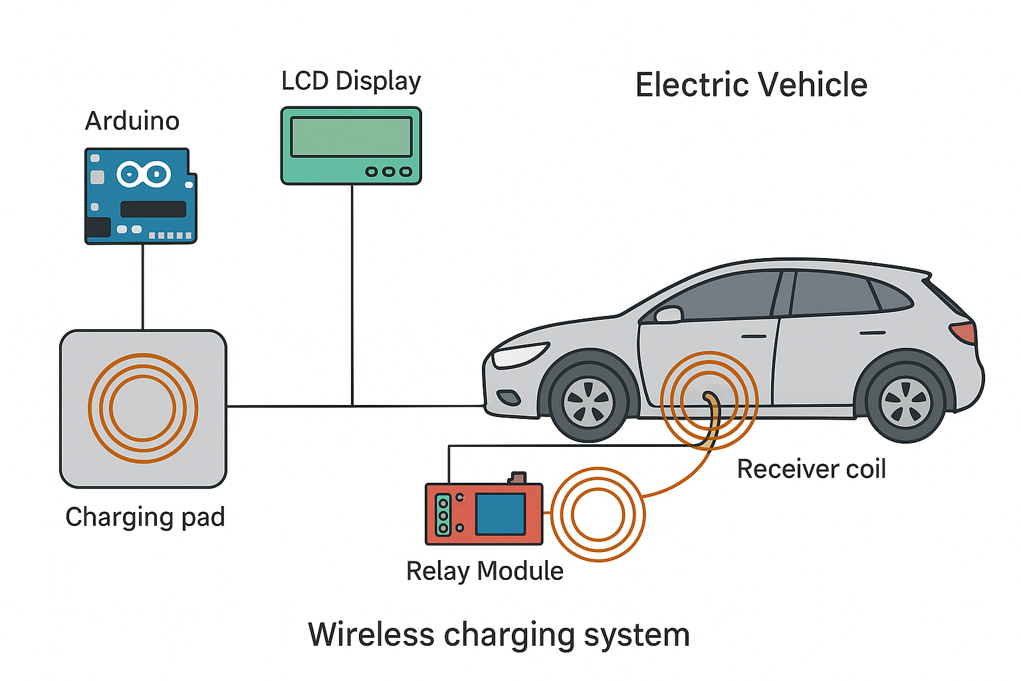

Figure 1.1: WIRELESS CHARGING SYSTEM

1.3 Objectives
➢ The objective of this project is to design and implement a wireless charging prototype for electric vehicles. The system efficiently transfers power over a small air gap, demonstrating feasibility for real-world use.

1.4 Layout of thesis
Chapter 2: Literature Survey
Chapter 3: Hardware/ Software Implementation
Chapter 4: Result
Chapter 5: Conclusion

Chapter 2

LITERATURE SURVEY
  - INTRODUCTION
[1]. Kurs, A Karalis, “Wireless power transfer via strongly coupled magnetic resonances,” Science, vol. 317, no. 5834, pp. 83–86, 2007.

This pioneering study demonstrated efficient mid-range wireless power transfer using strongly coupled magnetic resonances. It laid the foundation for modern wireless power transfer systems by proving the feasibility of contactless energy transmission

[2]. S. D. Barman, A.W. Reza, N. Kumar, “Wireless powering by magnetic resonant coupling: Recent trends in wireless power transfer system and its applications,”

This review highlights advancements in magnetic resonant coupling-based wireless power transfer, focusing on system design, energy efficiency, and real-world applications such as electric vehicle charging and biomedical devices.

[3]. X. Zhang, Y. Yuan., Q. Yang, “Coil design and efficiency analysis for dynamic wireless charging system for electric vehicles,” IEEE Transactions on Magnetics, vol. 52, no. 7, pp. 1–4,2016
This paper investigates the optimization of coil geometry and positioning for dynamic (in-motion) wireless EV charging. The study provides analytical and simulation-based results to enhance power transfer efficiency.
[4]. A.N. Azad, V. A. Kulyukin, R. Zane, R pantic, “Analysis, optimization, and demonstration of a vehicular detection system intended for dynamic wireless charging applications,” IEEE Transactions on Transportation Electrification, vol. 5, no. 1, pp. 147–161, 2019
The authors propose a vehicle detection and alignment system that improves charging accuracy in dynamic wireless charging scenarios. It integrates optimization methods for efficient and safe power transmission during vehicle movement

2.2 METHODOLOGY
The wireless electric vehicle charging system operates by first using an IR sensor to detect the presence of a vehicle within the charging zone. Once detection occurs, the microcontroller receives this signal through its input pin and begins processing. The microcontroller then activates the display unit (LCD) via its assigned output pin to show system status and operational messages. Simultaneously, the controller triggers a relay through another output pin, which in turn powers the transmission coils responsible for generating the electromagnetic field required for wireless power transfer. The power transmission coils transfer energy to the vehicle’s receiver coil, enabling contactless charging. Throughout the process, grounding connections ensure system stability and safety. This method ensures an automated, efficient, and user-friendly wireless charging experience for electric vehicles.

Chapter 3

HARDWARE & SOFTWARE IMPLEMENTATION

3.1 INTRODUCTION

Wireless electric vehicle charging system controlled by an Arduino. The power supply provides regulated power to the Arduino and other components. IR sensors and the RFID module send input signals to the Arduino for vehicle detection and user authentication. Based on these inputs, the Arduino displays system status on the LCD and controls the relay. The relay switches the power to the transmission coils, enabling wireless power transfer only when valid conditions are met. This ensures safe, secure, and automated charging operation.

3.2 BLOCK DIAGRAM
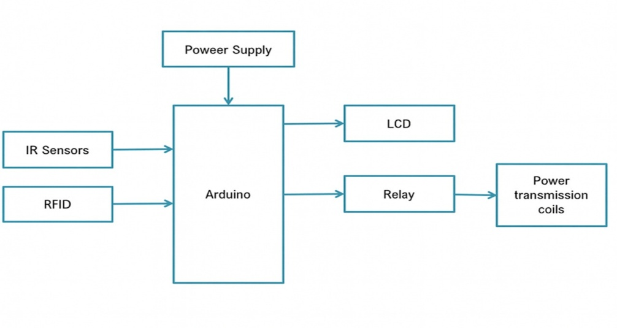
Figure 3.1: Block Diagram of the Project
The block diagram depicts the total blue print of the proposed project. The total essence and the functioning of the project are represented in a single block diagram.

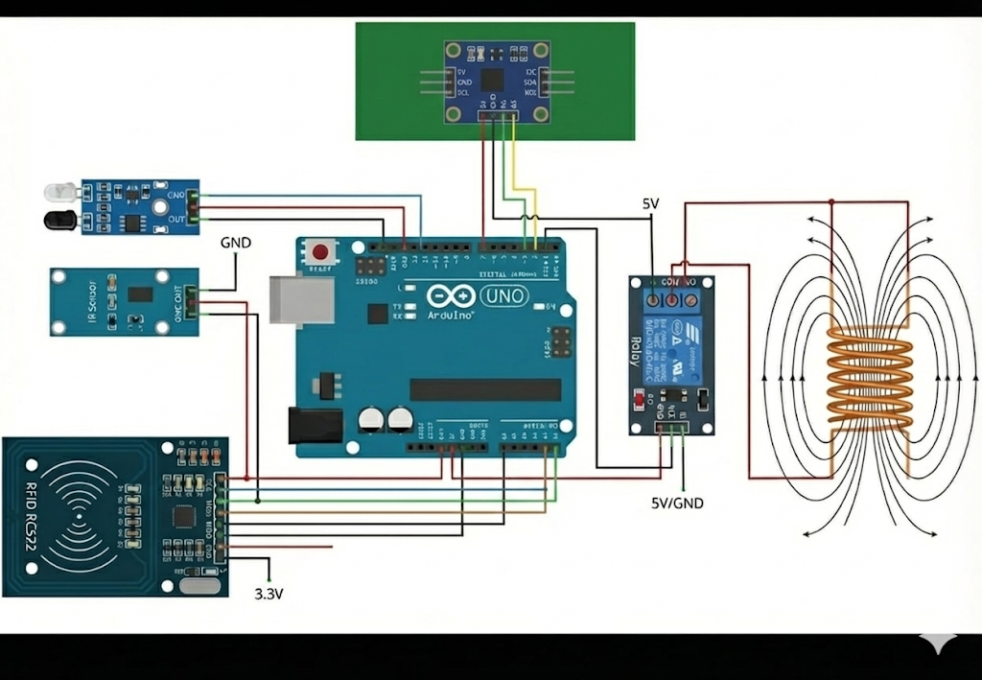
Figure 3.2: Circuit Diagram of the Project

Hardware Requirements
- Arduino UNO
- IR Sensor Module
- Connecting Wires/ Jumper Wires
- Liquid Crystal Display
- Wireless Power Transmission Coil
- Relay Module
- RFID

Software Requirements
1. Arduino IDE
3.3 Arduino UNO

The Arduino UNO is an open source microcontroller board based on microchip Atmege328p microcontroller and developed by Arduino.cc. The board is equipped with sets of digital and analog input output pins that may be interfaced to various expansion boards and other circuits. The board has 14 digital I/O pins (six capable of PWM output), 6 analog I/O pins, and is programmable with the Arduino IDE (Integrated Development Environment), via a type B USB Cable. It can be powered by the USB Cable or by an external 9-volt Battery, though it accepts voltages between 7 and 20 volts. It is similar to the Arduino Nano and Leonardo. The Hardware reference design is distributed under a creative commons attribution share-Alike 2.5 License and is available on the Arduino website. Layout and production files for some versions of the hardware are also available.

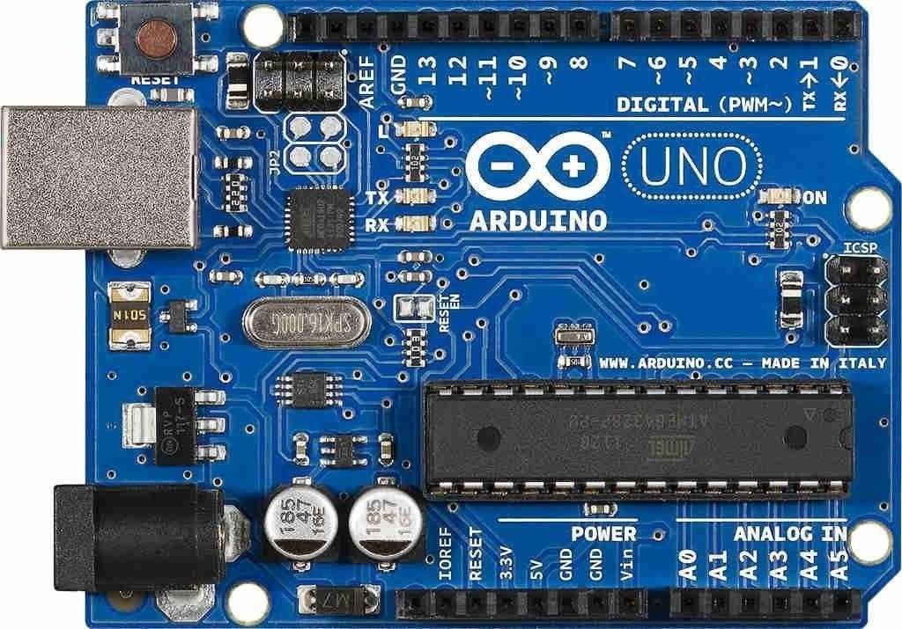
Figure 3.3: Arduino UNO Circuit
The Arduino/Genuino UNO has a number of facilities for communicating with a computer, another Arduino/Genuino board, or other microcontrollers. The ATmega328 provides UART TTL (5V) serial communication, which is available on digital pins 0 (RX) and 1 (TX). An ATmega16U2 on the board channels this serial communication over USB and appears as a virtual com port to software on the computer. The 16U2 firmware uses the standard USB COM drivers, and no external driver is needed. However, on Windows, a .inf file is required. Arduino Software (IDE) includes a serial monitor which allows simple textual data to be sent to and from the board. The RX and TX LEDs on the board will flash when data is being transmitted via the USB-to-serial chip and USB connection to the computer (but not for serial communication on pins 0 and 1). A Software Serial library allows serial communication on any of the Uno's digital pins.

Technical Specifications
- Microcontroller:MicrochipATmega328P^{[7]}
- Operating Voltage: 5 Volts
- Input Voltage: 7 to 20 Volts
- Digital I/O Pins: 14 (of which 6 can provide PWM output)
- UART: 1
- I2C: 1
- SPPI: 1
- Analog Input Pins: 6
- DC Current per I/O Pin: 20 mA
- DC Current for 3.3V Pin: 50 mA
- Flash Memory: 32 KB of which 0.5 KB used bybootloader
- SRAM: 2 KB
- EEPROM: 1 KB
- Clock Speed: 16 MHz
- Length: 68.6 mm
- Width: 53.4 mm
- Weight: 25 g

General Pin Functions
- LED: There is a built-in LED driven by digital pin 13. When the pin is high value, the LED is on, when the pin is low, it is off.
- VIN: The input voltage to the Arduino/Genuino board when it is using an external power source (as opposed to 5 volts from the USB connection or other regulated power source). You can supply voltage through this pin, or, if supplying voltage via the power jack, access it through this pin.
- 5V: This pin outputs a regulated 5V from the regulator on the board. The board can be supplied with power either from the DC power jack (7 - 20V), the USB connector (5V), or the VIN pin of the board (7-20V). Supplying voltage via the 5V or 3.3V pins bypasses the regulator, and can damage the board.
- 3V3: A 3.3 volt supply generated by the on-board regulator. Maximum current draw is 50 mA.
- GND: Ground pins.
- IOREF: This pin on the Arduino/Genuino board provides the voltage reference with which the microcontroller operates. A properly configured shield can read the IOREF pin voltage and select the appropriate power source, or enable voltage translators on the outputs to work with the 5V or 3.3V.
- Reset: Typically used to add a reset button to shields that block the one on the board.

Special Pin Functions
Each of the 14 digital pins and 6 analog pins on the Uno can be used as an input or output, under software control (using pin Mode(), digital Write(), and digital Read() functions). They operate at 5 volts. Each pin can provide or receive 20 mA as the recommended operating condition and has an internal pull-up resistor (disconnected by default) of 20-50K ohm. A maximum of 40mA must not be exceeded on any I/O pin to avoid permanent damage to the microcontroller. The Uno has 6 analog inputs, labeled A0 through A5; each provides 10 bits of resolution (i.e. 1024 different values). By default, they measure from ground to 5 volts, though it is possible to change the upper end of the range using the AREF pin and the analog Reference () function.
In addition, some pins have specialized functions:
- Serial /UART: pins 0 (RX) and 1 (TX). Used to receive (RX) and transmit (TX) TTL serial data. These pins are connected to the corresponding pins of the ATmega8U2 USB-to-TTL serial chip.
- External interrupts: pins 2 and 3. These pins can be configured to trigger an interrupt on a low value, a rising or falling edge, or a change in value.
- PWM(pulse-width modulation): pins 3, 5, 6, 9, 10, and 11. Can provide 8-bit PWM output with the analog Write() function.
- SPI(Serial Peripheral Interface): pins 10 (SS), 11 (MOSI), 12 (MISO), and 13 (SCK). These pins support SPI communication using the SPI library.
- TWI (two-wire interface) /I²C: pin SDA (A4) and pin SCL (A5). Support TWI communication using the Wire library.
- AREF (analog reference): Reference voltage for the analog inputs.

3.4 ATmega328P
The ATmega328 is a single – chip microcontroller created by Atmel in the mega AVR family later microchip technology acquired Atmel in 2016. It has a modified Harvard architecture 8bit RISC Processor core.
ATmega328 is commonly used in many projects and autonomous systems where a simple, low-powered, low-cost micro-controller is needed. Perhaps the most common implementation of this chip is on the popular Arduino development platform, namely the Arduino Uno and Arduino Nanomodels.
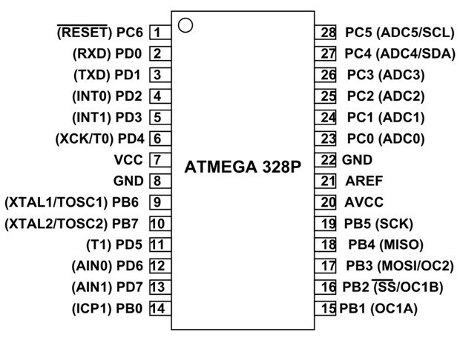
Figure 3.4: ATmega328P Microcontroller Pin Configuration
Specifications :
The Atmel 8-bit AVR RISC based microcontroller combines 32KB ISP flash memory with read while write capabilities, 1KB EEPROM, 2KB SRAM< 23 general purpose I/O lines, 32 general purpose working registers, three flexible timer/counters with compare modes, internal and external interrupts, serial programmable USART, a byte oriented 2 - wire serial interface, 6 channel 10bit ADC, programmable Watchdog timer with internal oscillator, and five software selectable power saving modes. The device operates between 1-1.85 volts,
1MIPS per MHZ

3.5 IR Sensor Module
The Infrared (IR) sensor module works by using infrared light to detect the presence, distance, or movement of an object without physical contact. It typically consists of two main components — an IR transmitter (infrared LED) and an IR receiver (photodiode or phototransistor). The IR transmitter continuously emits infrared light, which is invisible to the human eye. When an object comes within the sensing range, the emitted IR light hits the object’s surface and is reflected back toward the sensor. The IR receiver then detects this reflected light and generates an electrical signal based on its intensity. This signal is processed by a comparator circuit within the module, which compares the received signal with a reference value and produces a digital output — typically logic HIGH or LOW — to indicate whether an object is detected. The sensitivity and range of detection can usually be adjusted using a potentiometer on the module. In this way, the IR sensor module effectively detects obstacles, motion, or proximity, and is commonly used in robotics, automation, line-following robots, obstacle avoidance systems, and safety devices.

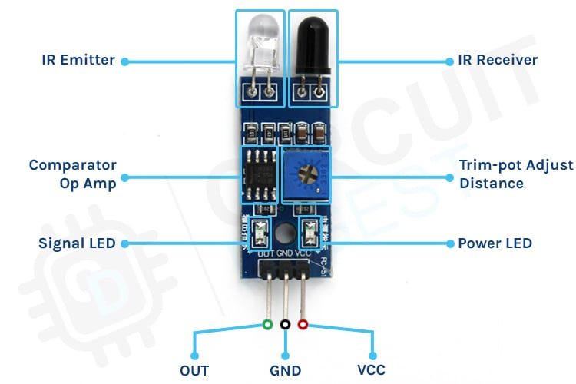
Figure 3.5 IR Sensor

3.6 Liquid Crystal Display (LCD)
In a Wireless Electric Vehicle (EV) Charging System, the Liquid Crystal Display (LCD) serves as an essential user interface that provides real-time monitoring and diagnostic information. Beyond just showing basic parameters like voltage, current, and charging status, the LCD can also display data such as coil alignment status, power transfer efficiency, temperature readings, and fault alerts. This helps the user or technician to ensure that the system is operating under optimal conditions and to identify issues such as coil misalignment, overcurrent, or overheating. The LCD, typically a 16x2 or 20x4 character module, is connected to a microcontroller (e.g., Arduino Uno), which continuously receives data from various sensors and updates the display accordingly. In advanced setups, the LCD can also show system mode (idle, charging, full-charge) and energy consumption statistics, making it a valuable tool for both performance analysis and user convenience. By offering a simple yet effective means of communication between the system and the user, the LCD significantly improves system transparency, control, and reliability in wireless EV charging applications.

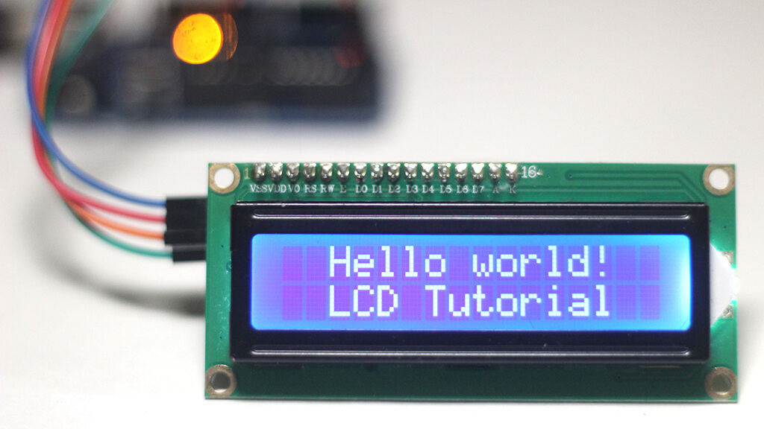
Figure 3.6 Liquid Crystal Display

3.7 Wireless Power Transmission Coils
The wireless power transmission coils play a crucial role in enabling the transfer of electrical energy without physical contact between the power source and the receiving device. In a wireless power transmission system, the transmitter coil (located in the charging pad or power station) is supplied with high-frequency alternating current, which generates a time-varying magnetic field around it. When the receiver coil (placed inside or beneath the device, such as an electric vehicle) is positioned within this magnetic field, an electromotive force (EMF) is induced in it according to Faraday’s Law of Electromagnetic Induction. This induced voltage produces an alternating current in the receiver coil, which is then rectified and regulated to provide stable direct current (DC) power for charging the battery or operating the electrical load. The efficiency of energy transfer between the two coils depends on their distance, alignment, size, and resonant frequency. When both coils are tuned to the same resonant frequency, resonant inductive coupling occurs, significantly improving power transfer efficiency. Thus, the transmitter and receiver coils together form the heart of a wireless charging system, enabling safe, efficient, and convenient energy transfer without the need for physical connectors.

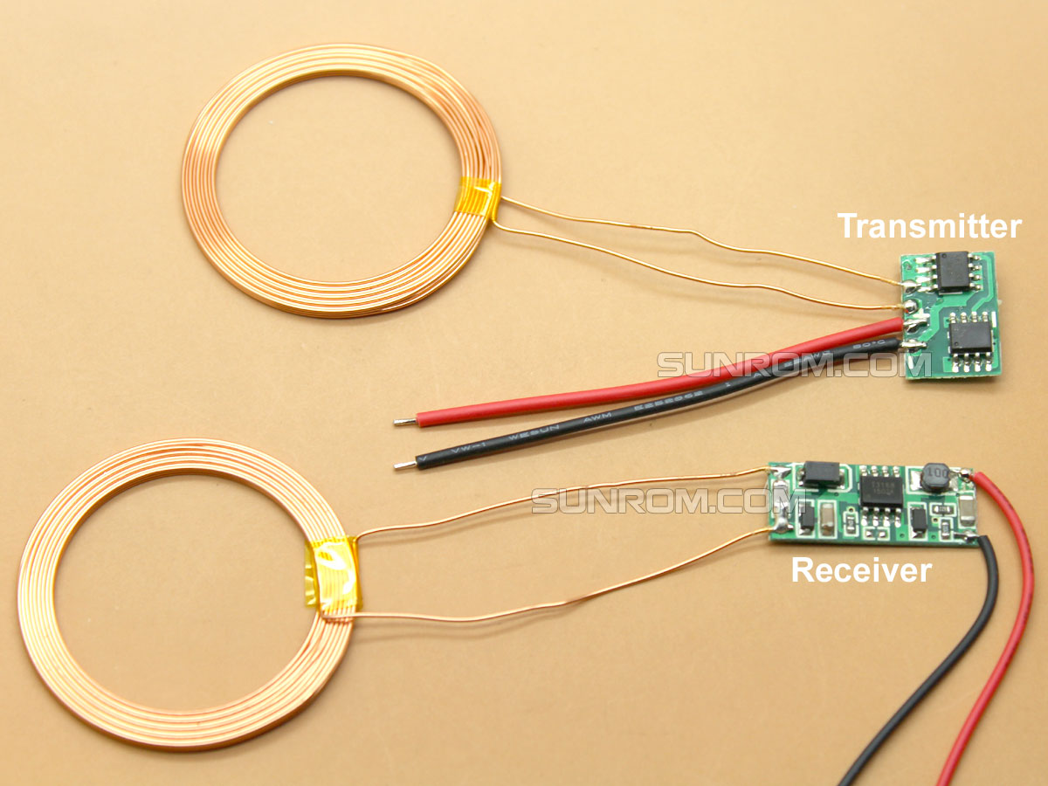
Figure 3.7 Wireless Power Transmission Coils

3.8 Relay Module
In a Wireless Electric Vehicle (EV) Charging System, the relay module plays a vital role in controlling the flow of electrical power and ensuring safety during operation. It acts as an electronically controlled switch that allows the microcontroller, such as an Arduino Uno, to turn the high-power charging circuit on or off based on system conditions. When the system detects that a vehicle is properly aligned and ready for charging (often through IR sensors or communication signals), the relay is activated to connect the power supply to the transmitter coil, initiating wireless energy transfer. Conversely, when the vehicle is removed or a fault is detected, the relay disconnects the circuit to prevent power loss or damage. This mechanism helps protect sensitive components from overcurrent, short circuits, and unwanted power flow. In addition, the relay module enables automation within the system by ensuring that charging occurs only under safe and efficient conditions.

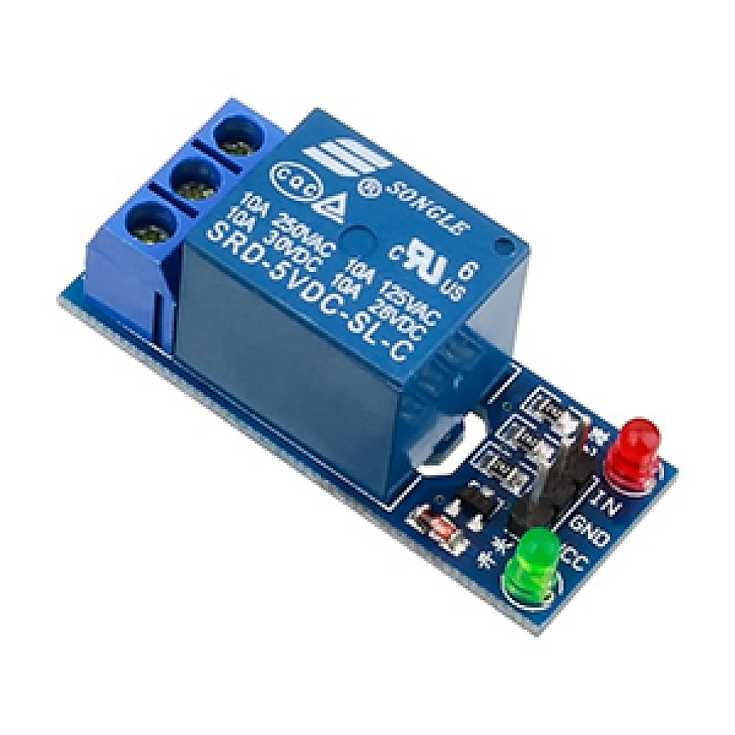
Figure 3.8 Relay Module

3.9 RFID

The RFID module is used for user or this confirmation, the Arduino activates the relay module. The relay then enables power flow to the power transmission vehicle authentication before enabling the wireless charging process. The RFID reader is connected to the Arduino and reads the unique ID from an RFID card or tag. When a valid tag is detected, the RFID module sends the identification data to the Arduino for verification. The Arduino compares this data with the pre-stored authorized IDs in its memory. If the ID is valid, the Arduino allows the system to proceed further. Based on coils. If an unauthorized RFID tag is detected, the relay remains OFF, preventing power transfer. The LCD displays the authentication status such as “Access Granted” or “Access Denied.” Thus, the RFID module adds an important layer of security to the wireless EV charging system.
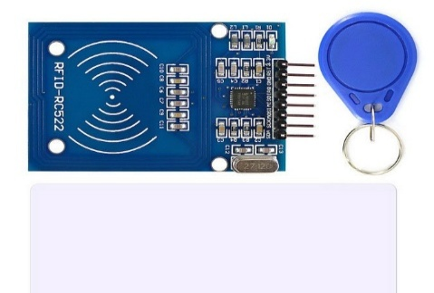
Figure 3.9 RFID

3.10 Arduino IDE
The Arduino Integrated Development Environment (IDE) is a cross platform application for Windows, MACOS, Linux that is written in functions from C and C++. It is used to write and upload programs to Arduino compatible boards, but also, with the help of third party cores, other vendor development boards. With the rising popularity of Arduino as a software platform, other vendors started to implement custom open source compilers and tools (cores) that can build and upload sketches to other microcontrollers that are not supported by Arduino official line of microcontrollers.
The source code for the IDE is released under the GNU General Public License, version 2. The Arduino IDE supports the languages C and C++using special rules of code structuring. The Arduino IDE supplies a software library from the Wiring project, which provides many common input and output procedures. User-written code only requires two basic functions, for starting the sketch and the main program loop, that are compiled and linked with a program stub main() into an executable cyclic executive program with the GNU tool chain, also included with the IDE distribution. The Arduino IDE employs the program avrdude to convert the executable code into a text file in hexadecimal encoding that is loaded into the Arduino board by a loader program in the board's firmware. By default, avr dude is used as the uploading tool to flash the user code onto official Arduino boards.
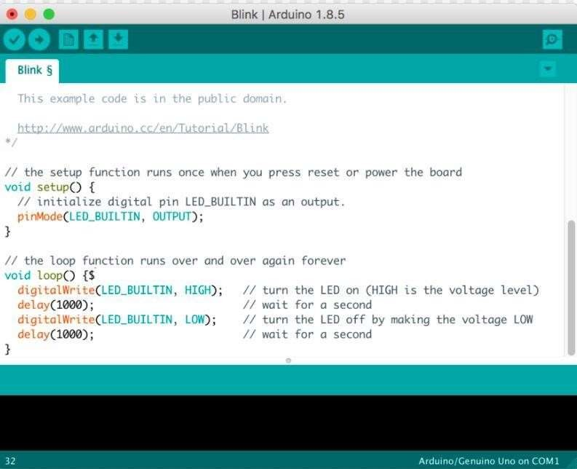
Figure 3.10 : Compilation of Source Code using Arduino IDE

3.11 Flow Chart/ Process of Project

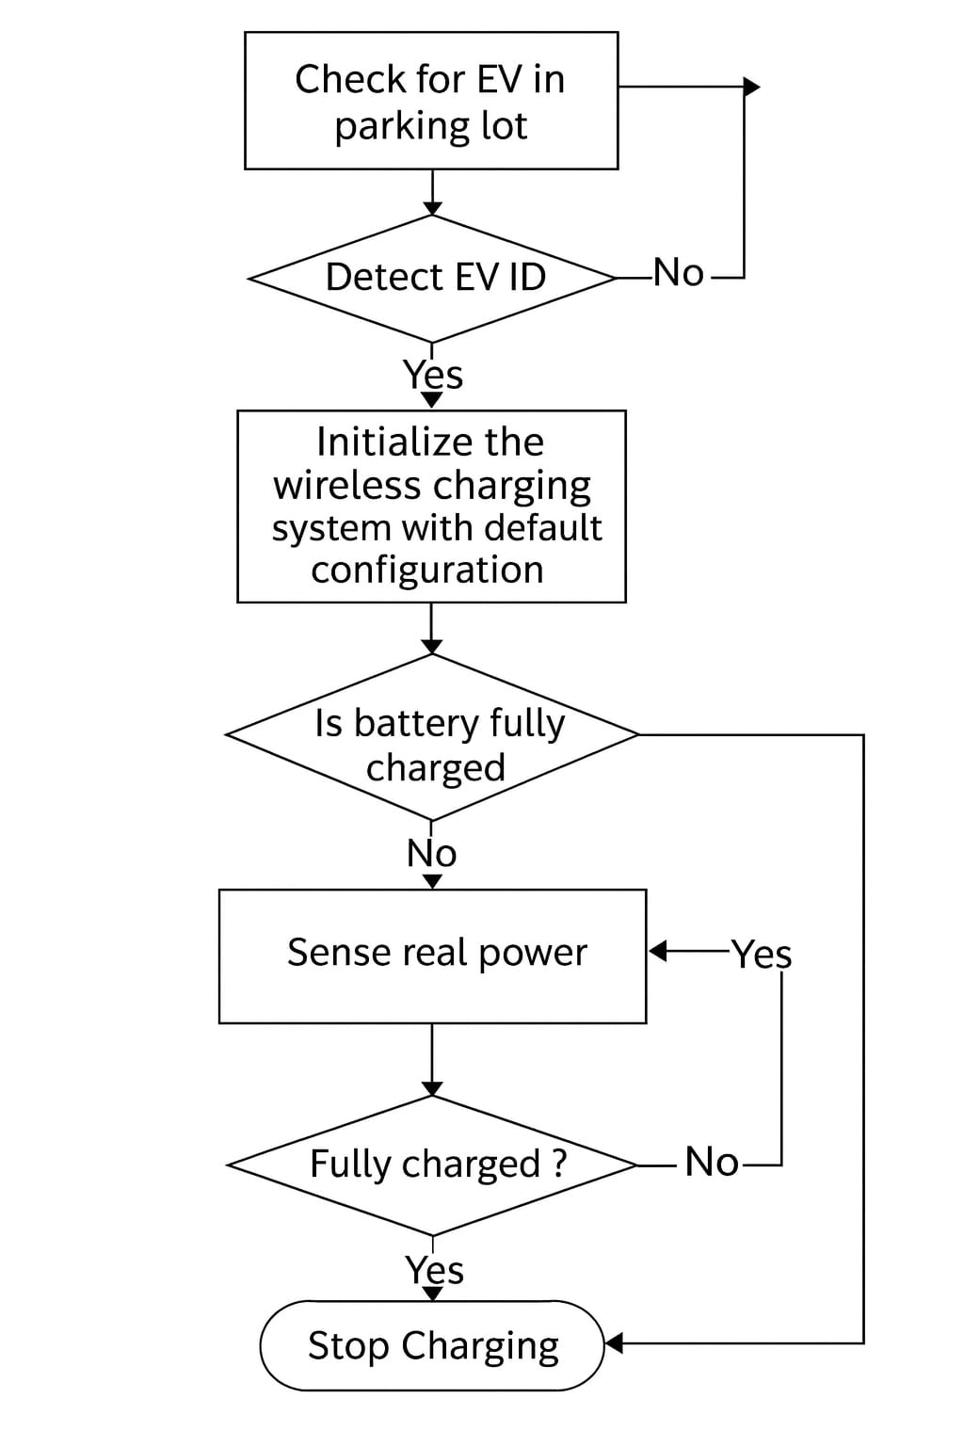
Figure 3.11 Flow chart

Explanation of the Flowchart
The flowchart shows the working process of a wireless electric vehicle (EV) charging system. First, the system checks whether an EV is present in the parking lot. If an EV is detected, the system verifies the EV’s ID to ensure it is authorized. Once confirmed, the wireless charging system is initialized with default settings. The system then checks if the EV battery is already fully charged. If not, it senses the real power being transferred to determine charging conditions. It then checks whether the current is at the maximum efficiency point; if not, the system tunes the frequency to improve power transfer. Charging continues in a loop while the battery is not full. When the battery becomes fully charged, the system stops charging automatically.

Chapter 4

RESULTS

4.1 Working Of The Project:

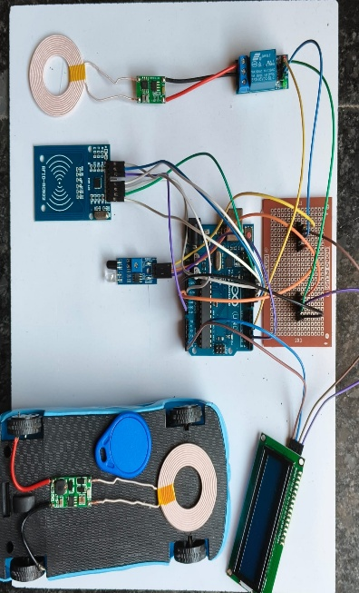

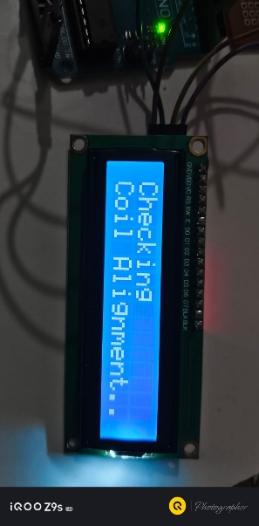
Figure 4.1 Wireless electric vehicle charging system kit
- Wireless electric vehicle charging system kit is consists of Electric Vehicles, Arduino, IR Sensors, Power supply, Relay, Power Transmission, Receiver Coils, Real-time Charging and RFID.

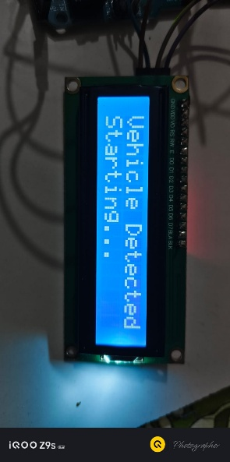

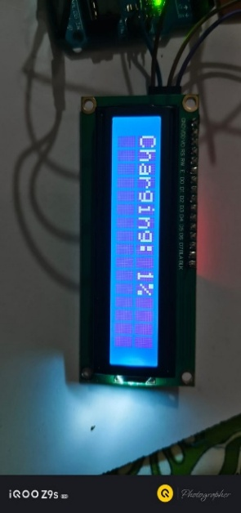
- Step-1: When the vehicle come in the contact with the coil, It check the alignment with the vehicle

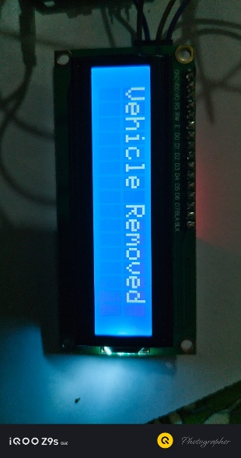

- Step-2: After checking the alignment the vehicle gets charged.
- Step-3: Then after hitting the required percentage the vehicle moves.

Chapter 5

CONCLUSION

5.1 Conclusion
The Wireless Electric Vehicle Charging System using Arduino represents a significant advancement in wireless power transfer (WPT) technology by overcoming limitations of conventional charging methods through the integration of modern microcontroller technology, advanced sensors, and optimized circuit design. The proposed system offers a reliable, efficient, and user-friendly solution with enhanced convenience, improved safety, and higher efficiency, demonstrating the potential of WPT to revolutionize power transmission for electric vehicles. A functional prototype has been developed to showcase the practical implementation of WPT principles, enabling applications such as automatic charging in public parking areas, support for smart city EV infrastructure, wireless charging of electric buses and taxis at stations, powering autonomous and self-driving vehicles, and supplying energy to industrial EVs like forklifts and AGVs. Additionally, the system provides key advantages including faster charging speeds of up to 100 kW, improved safety with reduced risk of electrical shock or fire, and greater scalability and flexibility for large-scale deployment.

5.2 Future scope

Dynamic wireless charging embedded in roads is expected to enable electric vehicles to charge continuously while driving, reducing range anxiety and the need for frequent stops. At the same time, higher-power wireless charging systems will allow faster and more efficient energy transfer, making wireless charging comparable to conventional plug-in methods. Widespread integration with smart grids will support automated energy management, real-time monitoring, and seamless billing, improving overall efficiency and user convenience. In addition, the development of standardized global interoperability will ensure compatibility across all EV models and charging platforms. These advancements will also encourage adoption in autonomous vehicles, enabling fully hands-free, self-managed charging without human intervention.

REFERENCES
[1]. A. Kurs, A. Karalis, R. Moffatt, J. D. Joannopoulos, P. Fisher ,M. Soljačić, “Wireless power transfer via strongly coupled magnetic resonances”, Science 317 (5834) (2007) 83-86.
[2]. S. Chhawchharia , S. K. Sahoo, M. Balamurugan, S. Sukchai ,F. Yanine, “Investigation of wireless power transfer applications with a focus on renewable energy”, Renewable and Sustainable Energy Reviews 91 (2018) 888-902.
[3]. S. D. Barman, A. W. Reza, N. Kumar, M. E. Karim, A. B. Munir, “Wireless powering by magnetic resonant coupling: Recent trend sin wireless power transfer system and its applications”, Renewable and Sustainable Energy Reviews 51 (2015) 1525-1552.
[4]. X. Zhang, Z. Yuan, Q. Yang, Y. Li, J. Zhu, Y. Li, “Coil design and efficiency analysis for dynamic wireless charging system for electric vehicles”, IEEE Transactions on Magnetics 52 (7) (2016) 1-4.
[5]. A. N. Azad, A. Echols, V. A. Kulyukin, R. Zane, Z. Pantic, “Analysis, optimization, and demonstration of a vehicular detection system intended for dynamic wireless charging applications”, IEEE Transactions on Transportation Electrification 5 (1) (2019) 147-161.
[6]. M. Longo, D. Zaninelli, G. Cipriani, V. Di Dio, R. Miceli, “Economic analysis on the use of wired and wireless recharging systems”, in:2017 IEEE International Conference on Environment and Electrical Engineering and 2017 IEEE Industrial and Commercial Power Systems Europe (EEEIC/ I CPS Europe), 2017, pp. 1-6.
[7]. F. M. Eltoumi, M. Becherif, A. Djerdir, H. Ramadan, “The key issues of electric vehicle charging via hybrid power sources:Techno-economic viability, analysis”, and recommendations, Renewable and Sustainable Energy Reviews 138 (2021) 110534.
[8]. D. M. Vilathgamuwa , J. P. K. Sampath, “Wireless Power Transfer (WPT) for Electric Vehicles (EVS) Present and Future Trends”, Springer Singapore, Singapore, 2015, pp. 33-60.
[9]. A. Vallera, P. Nunes, M. Brito, “Why we need battery swapping technology”, Energy Policy 157 (2021) 112481.
[10]. F. Tuchnitz , N. Ebell, J. Schlund, M. Pruckner, “Development and evaluation of a smart charging strategy for an electric vehicle fleet based on reinforcement learning”, Applied Energy 285 (2021) 116382.

APPENDIX
CODE
#include <LiquidCrystal_I2C.h>
#include <SPI.h>
#include <MFRC522.h>

LiquidCrystal_I2C lcd(0x27, 16, 2);

#define IR_sensor 2
#define RelayPin 4

#define SS_PIN 10
#define RST_PIN 9
MFRC522 rfid(SS_PIN, RST_PIN);

unsigned long chargeStart = 0;
bool charging = false;
int chargePercent = 0;

int updateInterval = 60; // increase 1% every 60 seconds

// YOUR ALLOWED RFID TAG UID (change these to your UID)
byte allowedUID1[] = {0xD7, 0xAC, 0xA6, 0x05}; // Blue tag
byte allowedUID2[] = {0x72, 0xC0, 0x56, 0x5C}; // White card

bool checkUID(byte *tag, byte *allowed) {
for (byte i = 0; i < 4; i++) {
if (tag[i] != allowed[i]) return false;
}
return true;
}

void setup() {
lcd.init();
lcd.backlight();

SPI.begin();
rfid.PCD_Init();

pinMode(IR_sensor, INPUT);
pinMode(RelayPin, OUTPUT);
digitalWrite(RelayPin, LOW);

lcd.clear();
lcd.setCursor(0, 0);
lcd.print("Wireless Charging");
delay(1500);
}

void loop() {

int IR_state = digitalRead(IR_sensor);

// ------------------------------
// 1) IR must detect vehicle
// ------------------------------
if (IR_state == HIGH) {
charging = false;
digitalWrite(RelayPin, LOW);
lcd.clear();
lcd.print("Waiting for");
lcd.setCursor(0, 1);
lcd.print("Vehicle...");
delay(500);
return;
}

// ------------------------------
// 2) Vehicle detected, ask for RFID
// ------------------------------
lcd.clear();
lcd.setCursor(0, 0);
lcd.print("Vehicle Detected");
lcd.setCursor(0, 1);
lcd.print("Scan RFID...");
delay(500);

// Wait for RFID scan
while (!rfid.PICC_IsNewCardPresent() || !rfid.PICC_ReadCardSerial()) {
if (digitalRead(IR_sensor) == HIGH) {
lcd.clear();
lcd.print("Waiting for");
lcd.setCursor(0, 1);
lcd.print("Vehicle...");
return;
}
}

bool authorized = checkUID(rfid.uid.uidByte, allowedUID1) ||
checkUID(rfid.uid.uidByte, allowedUID2);

if (!authorized) {
lcd.clear();
lcd.print("Unauthorized");
lcd.setCursor(0, 1);
lcd.print("Vehicle!");
delay(1500);
return;
}

lcd.clear();
lcd.print("RFID Verified!");
delay(1000);

// ------------------------------
// 3) Coil Alignment Message
// ------------------------------
lcd.clear();
lcd.print("Please Check");
lcd.setCursor(0, 1);
lcd.print("Coil Alignment");

// 4–5 seconds invisible wait
for (int i = 0; i < 5; i++) {
delay(1000);
if (digitalRead(IR_sensor) == HIGH) {
lcd.clear();
lcd.print("Waiting for");
lcd.setCursor(0, 1);
lcd.print("Vehicle...");
return;
}
}

// ------------------------------
// 4) Start countdown
// ------------------------------
for (int i = 5; i >= 1; i--) {

if (digitalRead(IR_sensor) == HIGH) {
lcd.clear();
lcd.print("Waiting for");
lcd.setCursor(0, 1);
lcd.print("Vehicle...");
return;
}

lcd.clear();
lcd.print("Starting...");
delay(1000);
}

// ------------------------------
// 5) Start charging
// ------------------------------
charging = true;
chargeStart = millis();
digitalWrite(RelayPin, HIGH);

while (charging) {

if (digitalRead(IR_sensor) == HIGH) {
charging = false;
digitalWrite(RelayPin, LOW);
lcd.clear();
lcd.print("Waiting for");
lcd.setCursor(0, 1);
lcd.print("Vehicle...");
return;
}

unsigned long elapsed = (millis() - chargeStart) / 1000;

if (elapsed >= updateInterval) {
chargeStart = millis();
if (chargePercent < 100) chargePercent++;
}

lcd.clear();
lcd.print("Charging: ");
lcd.print(chargePercent);
lcd.print("%");

delay(500);
}
}

